Foxridge GID Fence Project
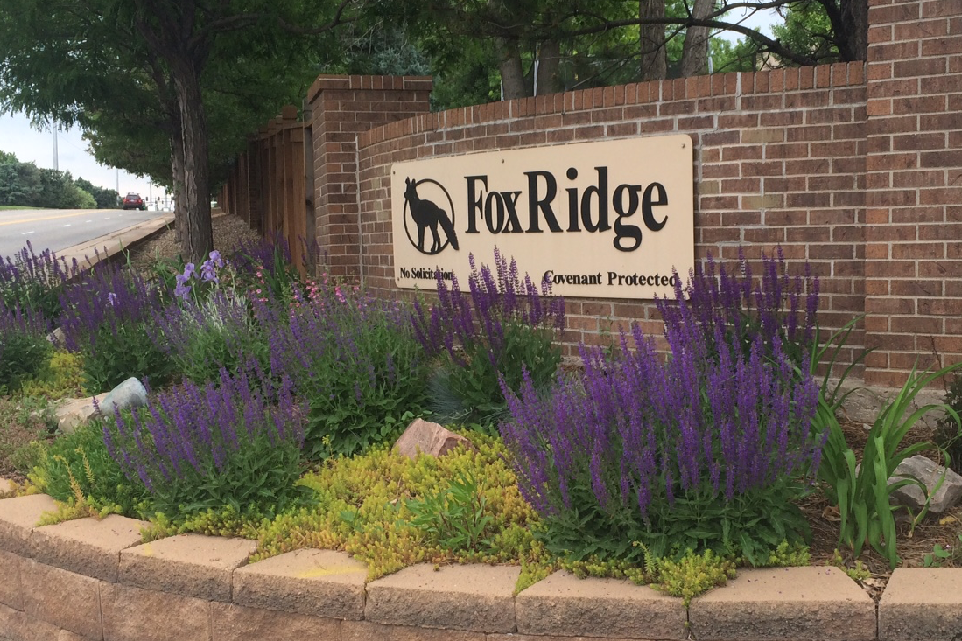
Information Sheet
Prepared by FGID Reps
Revised by City Attorney

Background Information:
Formation and Purpose: The Foxridge General Improvement District (GID) was established in 1990 by resolution of the Arapahoe County Commissioners and vote of the then registered electors of the GID. The GID imposes a small mill levy on homeowners’ property that provides funds to install and maintain certain improvements within the GID including fences and landscaping. Because there was no homeowners association, the GID installation and maintenance of these improvements has helped create a cohesive and attractive look to the neighborhood. Based on the current mill levy, the average payment per household is currently about $50 - $60/year or about $5 per month. The GID’s current annual revenue from the 934 homes totals about $55,000 a year. Funds are used for the following:

• Fence maintenance and repair, as well as replacement when needed
• Common area and street rights-of-way cleanup and weed eradication
• Irrigation system maintenance, operation, and repair
• Tree and shrub trimming, spraying and fertilizing
• Entrance utilities, care and improvements of entry gardens
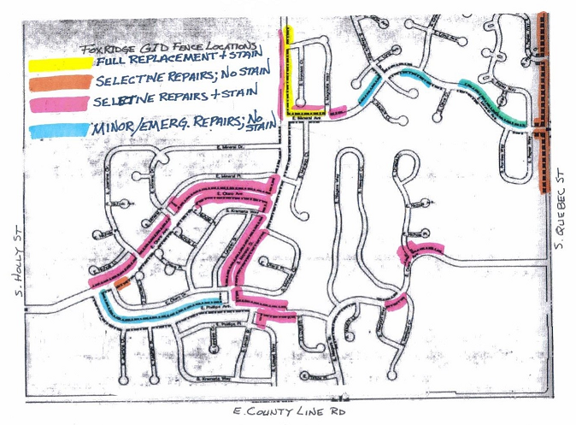
The Fences: GID fences are perimeter fences along
Quebec and interior thoroughfare street fences
such as those along Mineral Avenue, Otero Avenue
and Monaco - roughly 3 miles of fence.

The Issue:
The GID fences are roughly 25 years old; end of life for cedar fences with 4” x 4” wood posts, such as ours, is 20-30 years.

Why not simply replace them? Due to state constitutional and statutory limitations on property tax revenue growth (Tabor, Gallagher) along with annual maintenance costs, the GID has been unable to save sufficient money to replace all of the existing fence.

Original income was $45,000 a year. 26 years later income is only $55,000 a year.
Based on today’s dollar value, we should be getting $84,000, so we’re $30,000 short each year. $45,000 in 1990 equals $84,406 in 2016 dollars.

Financial Information:
Each year, roughly $30,000 is used for sprinklers, landscaping, maintenance, and city administrative fees, leaving $25,000 available for fencing. Since 2010, only critical repairs and staining have taken place, since it became evident that fences needed replacing and it wasn’t wise to waste money on fences that might be replaced. (Exception – 2010, a stretch along Monaco). FGID reserves have built to almost $200,000; we are budgeting $150,000 of that for fences…enough to replace roughly 20% of fences. Income years following would replace only 3-5% more each year. There isn’t enough income to replace the fences in phases over four or five years.
Solution Options:
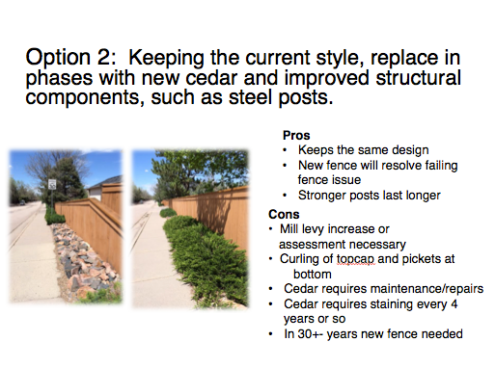
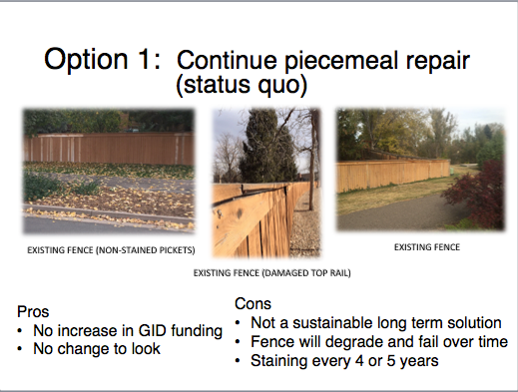
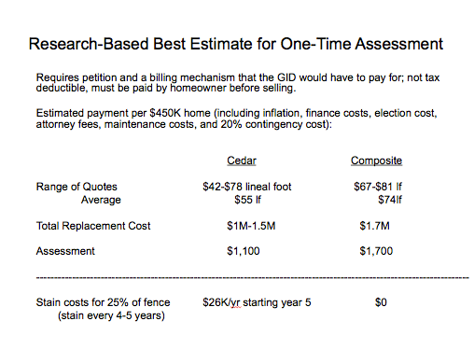
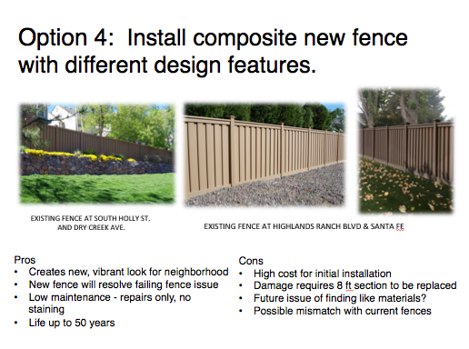
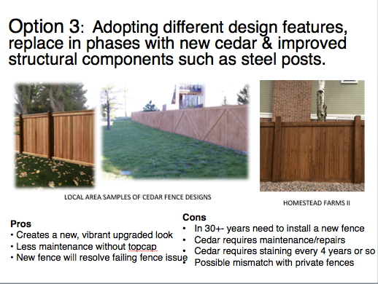

Financial Estimates - rough
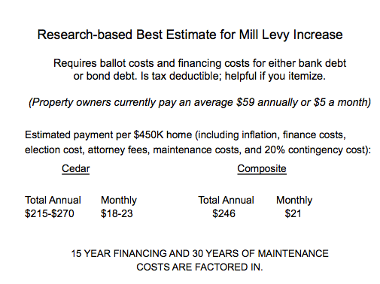

Clubhouse Exploration:

Occasionally, people express an interest in having a neighborhood clubhouse. Is it even possible or feasible? It will take research to find out. No sense spending time without knowing if there is strong interest.

Possible survey question: Are you in favor of exploring the feasibility of building a clubhouse (perhaps 2000 sq feet, capacity 75) in the neighborhood so that we have a year-round community gathering place for parties, meetings, and other social events?

If survey results show strong interest, a separate committee would be formed to research the feasibility.

Potential cost of clubhouse: $700K, plus land, interest, fees, etc. = $1 million (rough estimate)
Per household estimate $75 per year….with maintenance, insurance…$125 per year.

The Survey Process:

• The first feedback survey (administered by THK Associates in early Sept) will help us determine whether or not there is support for replacing our GID fences, and if so, gauge interest in cedar versus composite.

• If results indicate support for fence replacement, a follow-up survey will go out to show samples of fence style and color and gather feedback to help us choose.

• Once a style is selected, more accurate financials can be determined and we can plan next steps.

For More Information:

To receive updated information about the fence project, and to participate in the survey, send your email address to Sue Townsend at susantownsend75@gmail.com and read the monthly Foxtales.

You can also contact your GID reps, Martha Riley, Ed Bain, and Elliott Sutta at
Foxridge.gid.reps@gmail.com

